**Create TFAS- Missing CLO**

| Attribute | Value |
| --- | --- |
| Application ID / Application Name | BPP - CKT-VOICE |
| Owner | Rahul Bathla |
| Owner Contact Information | RB824N |
| Problem Abstract | Get- TFAS |
| Other Attribute | Missing CLO |

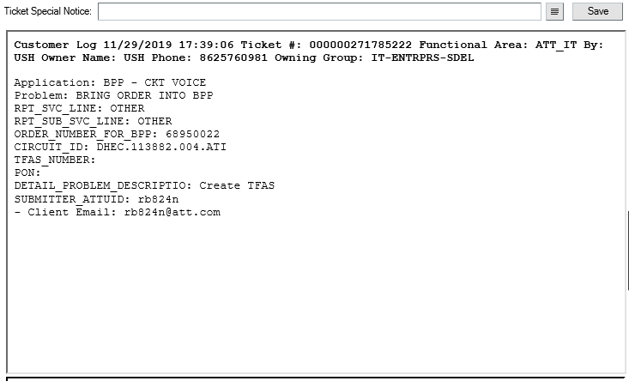

1. As usual we start work on any USO By going to sifuso Table

Screen Shot Below

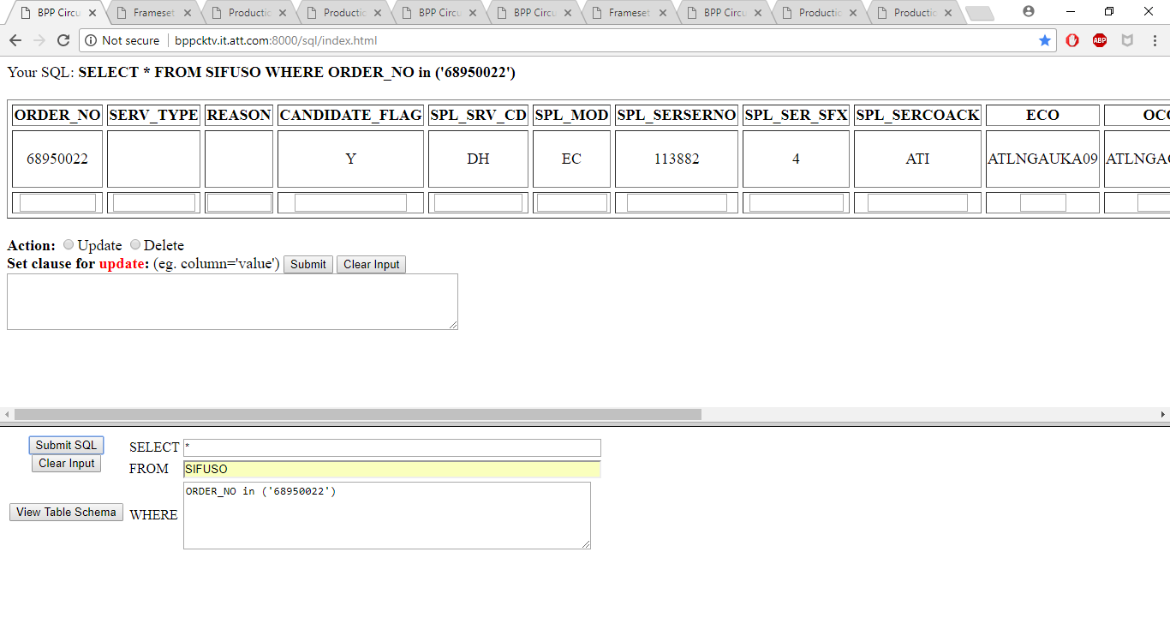2. Check The circuit if everything Looks ok

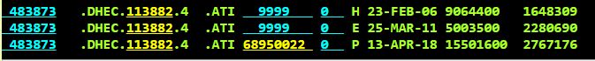

1. Two Important Hyperlinks to Retrieve CLO – Both marked by arrow on Screen on Get-keys Page

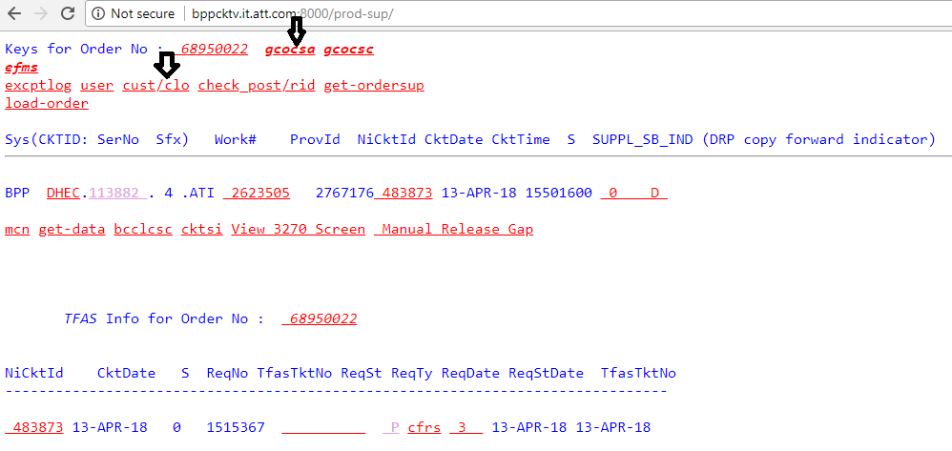

1. Get the CLO information from gcocsa screen Marker in screen shot. This Gcocsa screen is information from TIRKS

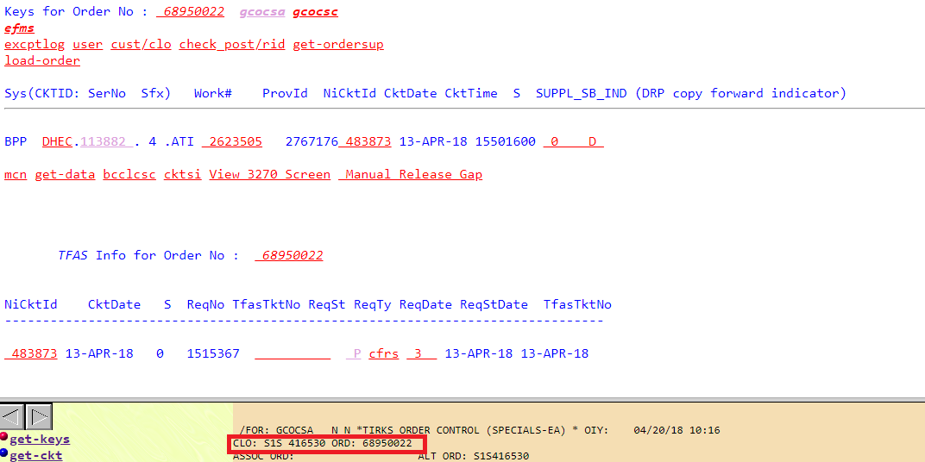

1. Get to Production script page- use script get-clo.

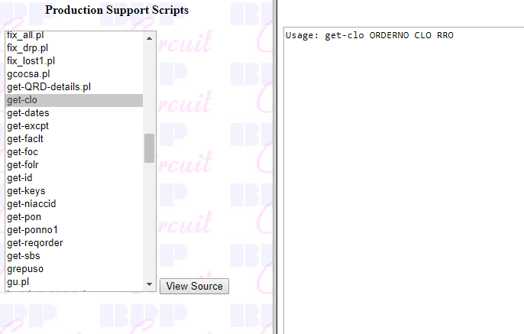

1. You have order number, get CLO from gcocsa screen and TSF in this case

68950022 S1S416530 TSF- Shown is Screen Shot

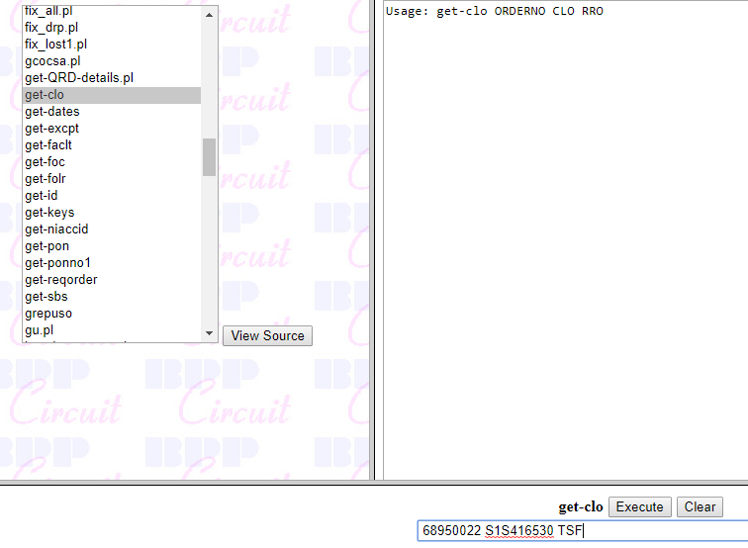

1. Go to Get-Keys Page and click hyperlink – cust/clo. You find the information ran through script.

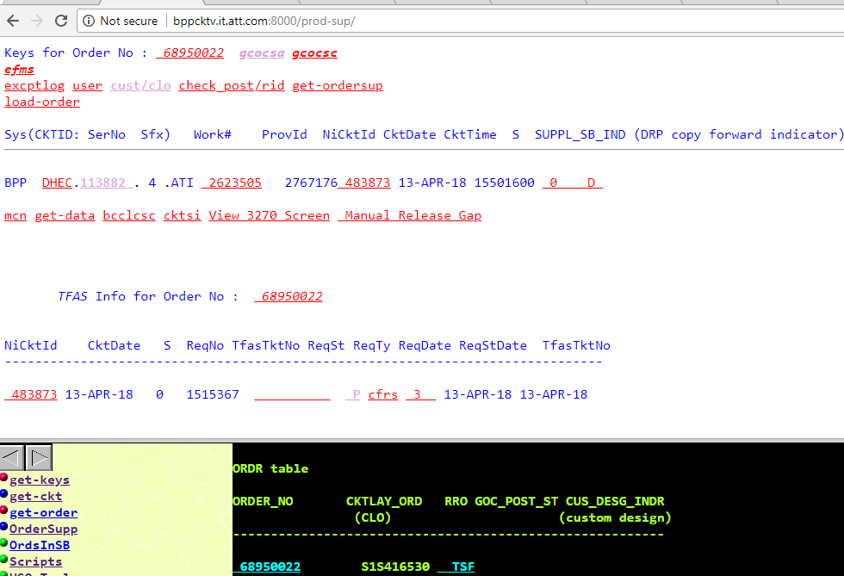

1. Go back to production Script page – Use the Script tgo2sb run the scheuling block Order is stuck at using Work number from Get-Keys Page. In this case scheduling block is 0400

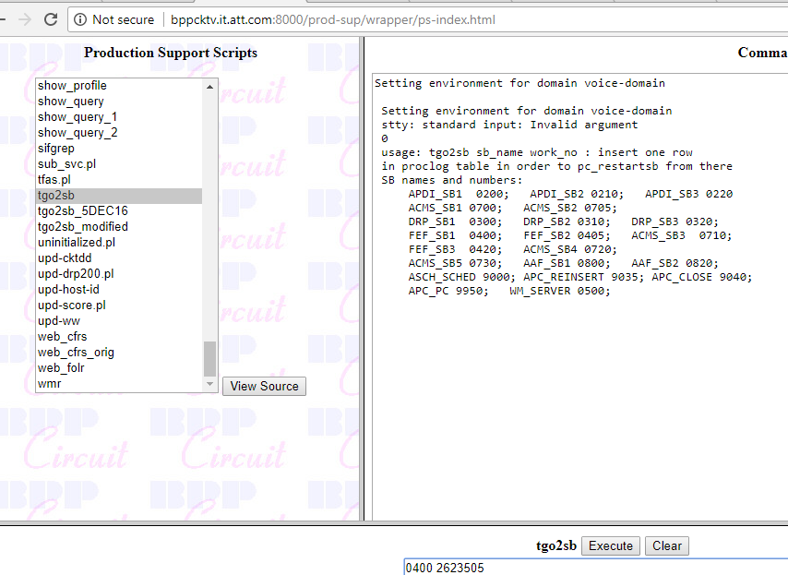

1. Click on work number on Get-Keys Page as shown Screen Shot. Check if it moved to desired scheduling block.

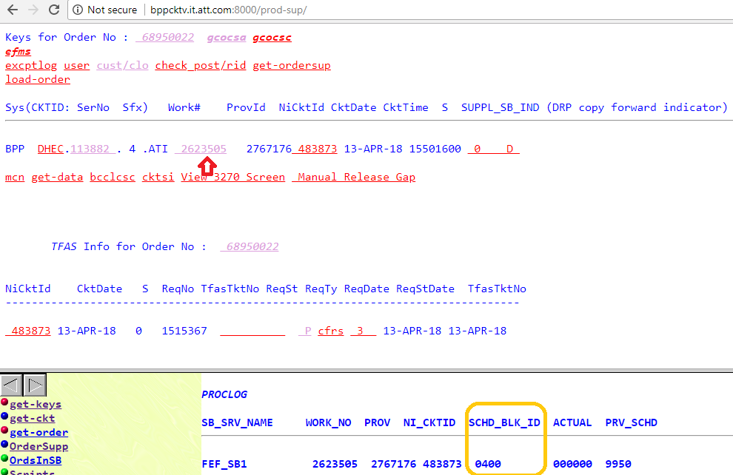

1. You will get the TFAS in this Case. So times you get this error while issuing word

